# Department of Computer Engineering

**Academic Term: July-November 2023**

# Rubrics for Lab Experiments

|  |  |  |
| --- | --- | --- |
| **Class** | **: B*.E. Computer*** | **Subject Name :*NLP*** |
| **Semester** | **: VII** | **Subject Code : *CSDC7023*** |

|  |  |
| --- | --- |
| **Practical No:** | **5** |
| **Title:** | **Hidden Markov Model** |
| **Date of Performance:** | **30/08/2023** |
| **Roll No:** | **9426** |
| **Name of the Student:** | **Atharva Prashant Pawar** |

**Evaluation:**

|  |  |  |  |  |  |
| --- | --- | --- | --- | --- | --- |
| **Performance Indicator** | **Below average** | **Average** | **Good** | **Excellent** | **Marks** |
| **On time Submission (2)** | Not submitted(0) | Submitted  after deadline (1) | Early or on time submission(2) | --- |  |
| **Test cases and** | Incorrect | The expected | The expected | Expected output is |  |
| **output** | output (1) | output is | output is Verified | obtained for all test |
| **(4)** |  | verified only a  for few test | for all test cases  but is | cases. Presentable and  easy to follow (4) |
|  |  | cases (2) | not presentable (3) |  |
| **Coding** | The code is not | The code is | The code is | - |  |
| **efficiency (2)** | structured at all  (0) | structured but  not efficient (1) | structured and  efficient. (2) |
| **Knowledge(2)** | Basic concepts not clear  (0) | Understood the basic concepts (1) | Could explain the concept with  suitable example (1.5) | Could relate the theory with real world  application(2) |  |
| **Total** |  | | | | |

Natural Language Processing (BE COMP – Sem-VII)

# Experiment – 5 Hidden Markov Model

**Aim:** To implement theHidden Markov model

## Task 1:

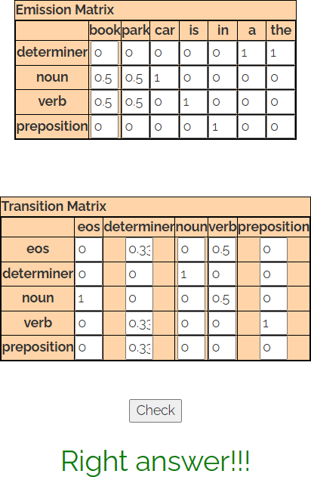

**Task 2:** Implement Calculation of emission probability and transition probability matrix using python code.

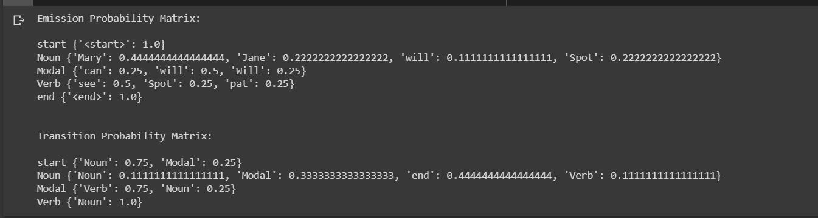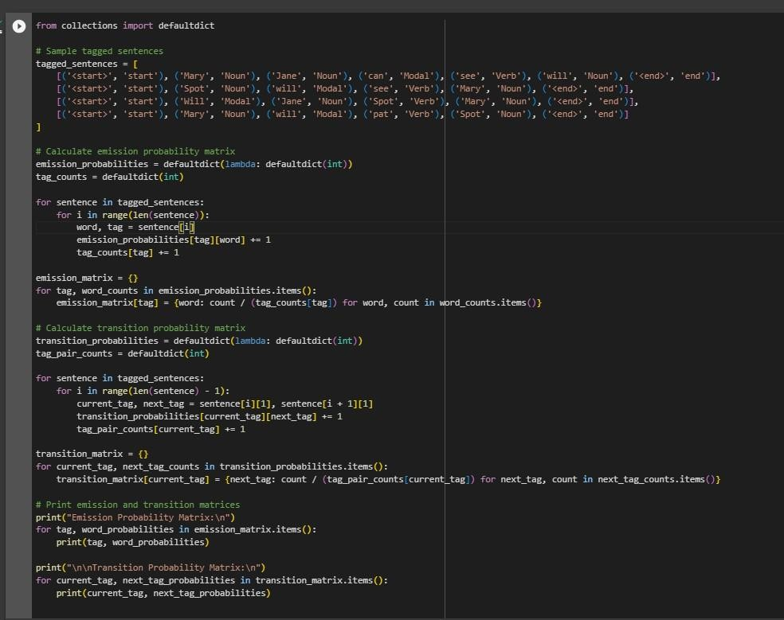

Post Lab questions:

1. 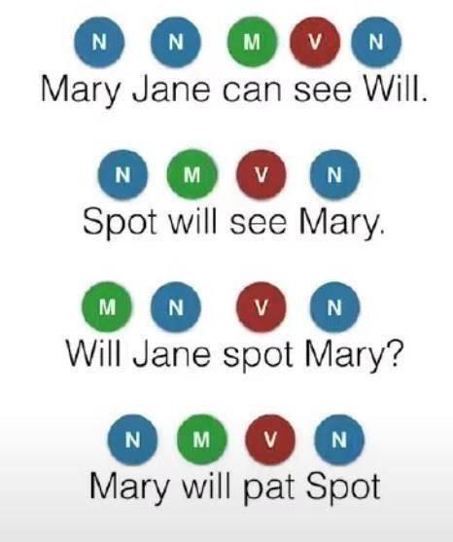Compute emission and transition matrix for the following example. Consider the following three Tags – Noun (N), Verb (V), Modal (M),

And check whether the following tagging is correct or not using HMM model.

## Will Marry Spot Jane?

|  |  |  |  |
| --- | --- | --- | --- |
| Will | Marry | Spot | Jane |
| Noun | Noun | Verb | Noun |

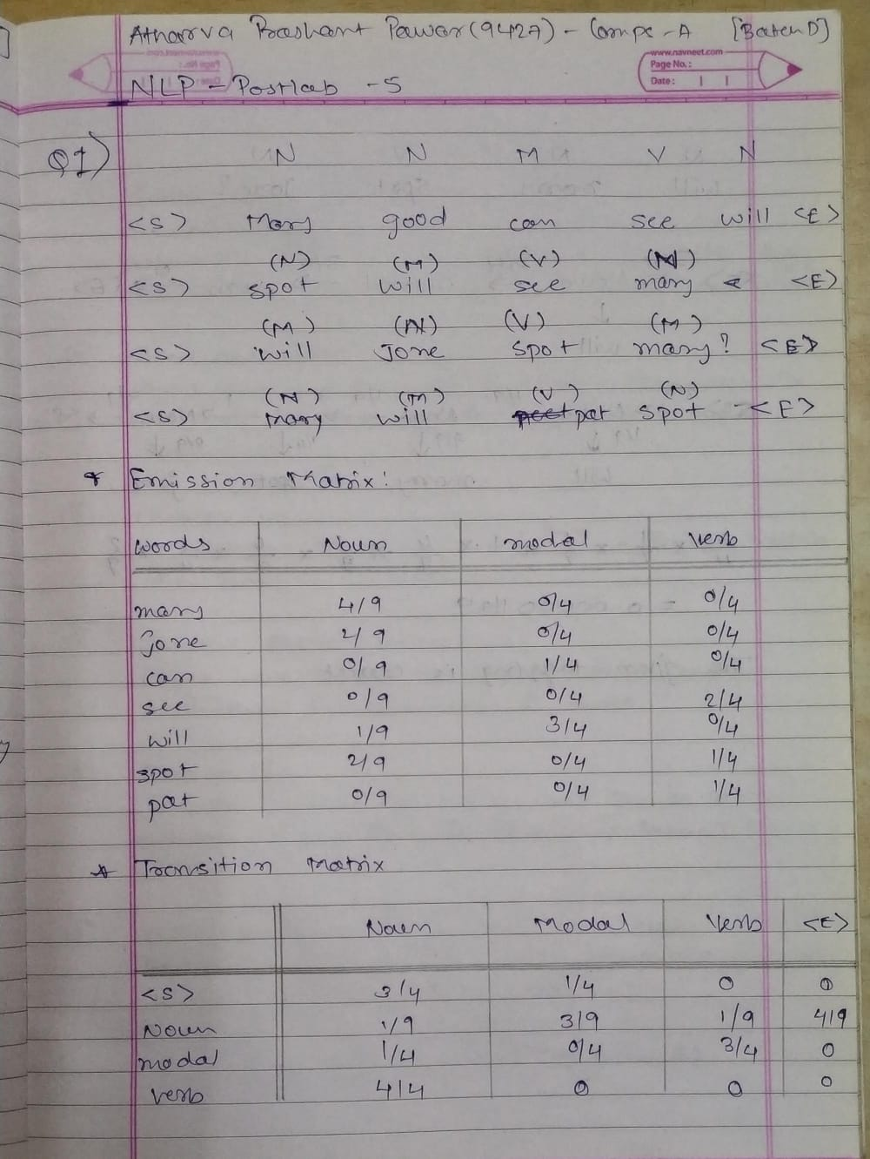

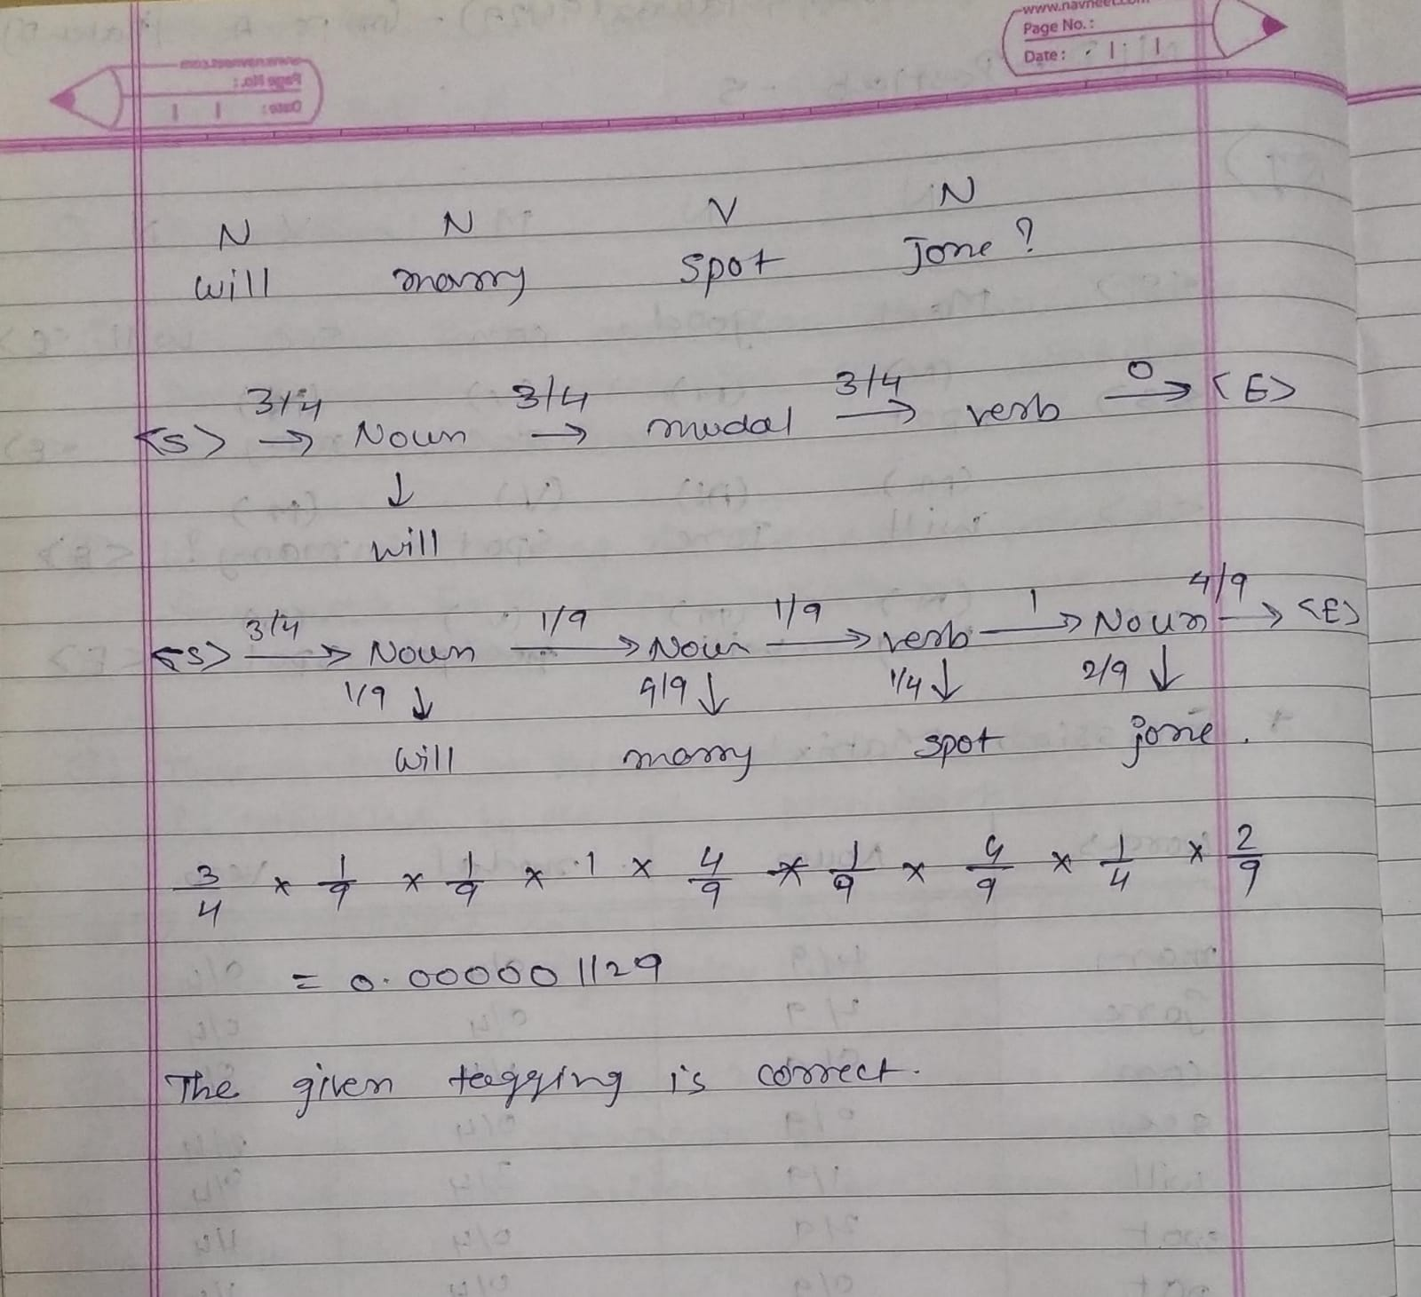

1. What are the limitations of HMM model? How do you overcome these limitations?

